**Bangabandhu Sheikh Mujibur Rahman Science and Technology University, Gopalganj-8100.**



**E-commerce Website**

**Course Code : CSE378 27 July, 2023**

**By:** Tushar SarkarID:18CSE035

**Department of Computer Science & Engineering Bangabandhu Sheikh Mujibur Rahman Science and Technology University**

**Ecommerce Website**

Submitted to the Department of Computer Science and Engineering, Bangabandhu Sheikh Mujibur Rahman Science and Technology University in partial fulfillment to the requirements for the degree of B.Sc. Engineering.

**By:** Tushar SarkarID:18CSE035

**Supervised By:**  Faruk Hossen Assistant Professor

**Department of Computer Science & Engineering Bangabandhu Sheikh Mujibur Rahman Science and Technology University**

# **DECLARATION**

I, **Tushar Sarkar** , **ID : 18CSE035** declare that the project consideration of degree of Bachelor of Computer Science & Engineering (CSE) embodies our own work with suggestion received during the work, which have been suitably acknowledge.

**Tushar Sarkar ID: 18CSE035**

…………………………. ………………….……...

Signature Date

# **APPROVAL**

I certify that this project “**E-commerce Websites**” is the original work of the above named candidate and has been done under my supervision. To the best of my knowledge and belief, this work which embodies the work of candidates themselves, has been duly completed, fulfills the requirement of the ordinance relating to the third year of Bangabandhu Sheikh Mujibur Rahman Science and Technology University and is up to standard in respect of content, presentation and language for being referred to the examiner. The work has never been submitted anywhere. It’s only submitted to Bangabandhu Sheikh Mujibur Rahman Science and Technology University.

**Project Supervisor :**

**Faruk Hossen**

Assistant Professor

Department of Computer Science and Engineering

Bangabandhu Sheikh Mujibur Rahman Science and Technology University, Gopalganj.

Signature:……………………. Date:……………….

# **ACKNOWLEDGEMENT**

Firstly I would like to express my deprest sense of gratitude to my reverend teacher and supervisors **Faruk Hossen**, Assistant Professor of Department of Computer Science & Engineering (CSE), Bangabandhu Sheikh Mujibur Rahman Science and Technology University. And for her untiring guidance, constant supervision, enthusiastic encouragement, sagacious advice and an effective surveillance throughout the entire period of my project and preparation of the manuscript. I greatly say thank you. Wish to express my heart full thanks to all of my honorable teachers of the department of Computer Science and Engineering (CSE), Bangabandhu Sheikh Mujibur Rahman Science and Technology University.

Secondly I would like to thank my department senior brother **Avilash Saha Akash, ID:17CSE035** who helped me a lot in finalizing this project within a limited time frame.

Tushar Sarkar

18CSE035

27 July, 2023

# **ABSTRACT**

The E-commerce Website project provides a concise overview of the key aspects of the development and implementation of an online shopping platform. This abstract summarizes the project's objectives, technologies used, core features, and overall impact on the target audience. The E-commerce Website project focuses on designing and deploying a fully functional and user-friendly online shopping platform to cater to the growing demand for convenient and secure shopping experiences. The primary objective is to provide customers with a seamless and intuitive shopping interface, ensuring easy navigation and access to a wide range of products. To achieve this, modern front-end technologies such as HTML5, CSS3, PHP, and responsive design principles are utilized to create an aesthetically pleasing and mobile-friendly user interface. The back-end development leverages robust server-side technologies like Laravel with the Express framework to process data efficiently and handle secure transactions. Upon successful deployment, the E-commerce Website will provide a competitive advantage to the business, leading to increased sales and customer satisfaction. As the e-commerce market continues to evolve, the project's adaptable structure prepares it for future enhancements and scalability to meet changing customer needs and market demands.

Overall, the E-commerce Website project demonstrates the importance of user-centric design, security, and modern technologies in creating a successful and sustainable online shopping platform in the ever-evolving landscape of e-commerce.

maagement in Institutes experience for both Students and the Adminstartion authorities. The whole

system will run on internet

report entitled “Bank Account Management System” submitted to City University **TABLE OF CONTENT**

**Table of Contents**

**DECLARATION** 1

**APPROVAL** 2

**ACKNOWLEDGEMENT** 3

**ABSTRACT** 4

**CHAPTER - 1 INTRODUCTION** 7

**1.1 Introduction:** 7

**1.2 Purpose:** 7

**1.3 Scope:** 8

**CHAPTER - 2 SYSTEM ANALYSIS** 9

**2.1 Existing System:** 9

**2.2 Proposed System:** 10

**2.3 Feasibility Analysis:** 11

**2.3.1 Technical Feasibility:** 11

**2.3.2 Economical Feasibility:** 11

**CHAPTER – 3 IMPLEMENTATION** 12

**3.1 Implementation:** 12

**3.1.1 PHP:** 12

**3.1.2 Bootstrap:** 13

**3.1.3 HTML:** 13

**3.1.4 XAMPP:** 14

**3.1.5 MySQL:** 14

**3.1.6 php MyAdmin:** 14

**3.2 System Design:** 15

**CHAPTER - 4 LIMITATION AND FUTURE SCOPE** 27

**4.1 Limitation:** 27

**4.2 Future Scope:** 28

**CHAPTER - 5 CONCLUSIONS** 29

**CHAPTER - 6** **REFERENCES** 30

**Figure Of Contents**

Figure 1: Homepage 1 16

Figure 2: Homepage 2 16

Figure 3: Login 17

Figure 4: Registration 17

Figure 5: View More 18

Figure 6: My Account 18

Figure 7: Add to Cart 19

Figure 8: Order 19

Figure 9: Payment 20

Figure 10: Admin Homepage 20

Figure 11: Insert Product 21

Figure 12: View Product 21

Figure 13: Insert Category 22

Figure 14: View Category 22

Figure 15: Insert Brand 23

Figure 16: View Brand 23

Figure 17: View Orders 24

Figure 18: View Payment 24

Figure 19: View Users 25

Figure 20: Sample Code 25

Figure 21: php MyAdmin 26

# **CHAPTER - 1**

# **INTRODUCTION**

## **1.1 Introduction:**

An E-commerce website requires appropriate strategy of successful design and implementation. Everything is required to plan from scratch to end of website. The e-commerce sector is seen the exponential growth thus a new option will easily part of this regatta of commercial website. The e-commerce website will feature the online shopping facility of various fashion products under a single web space. The proposed web application will allow business personnel to make their total business using it and increase their reachability thousands of times more than today they have, over the internet. It will allow multiple shopping vendors to sale their products online. The product management in the system will be done in the form of categories. The safety of information is the main requirement of the system and will be handling according to that. To formulate this project first task is to do is cost estimation. For probabilistic assessment of the project cost estimation is required. Cost estimation covers the accurate; estimations of cost and effort required for the project.

## **1.2 Purpose:**

The primary purpose of an e-commerce website is to facilitate online transactions and enable businesses to sell their products or services to customers over the internet. E-commerce websites act as virtual storefronts, allowing businesses to reach a global audience and provide customers with a convenient and seamless shopping experience. The key purposes of an e-commerce website include:

**Online Sales:** The fundamental purpose of an e-commerce website is to showcase products or services and enable customers to make purchases directly through the platform. Customers can browse through the product catalog, add items to their shopping cart, and complete the purchase using various payment methods.

**Global Reach:** Unlike physical stores with geographical limitations, e-commerce websites break down barriers and allow businesses to reach customers all around the world. This expands the market reach and potential customer base exponentially.

**Convenience:** E-commerce websites provide unmatched convenience to customers. Shoppers can access the website at any time, day or night, and make purchases from the comfort of their homes or on the go using their computers, smartphones, or tablets.

In summary, the purpose of an e-commerce website is to create a digital platform that connects businesses with customers, enabling seamless online transactions and offering a user-friendly shopping experience. By leveraging the power of e-commerce, businesses can thrive in the digital age and tap into a global market to grow their brand and increase revenue.

## **1.3 Scope:**

The scope of an e-commerce website is immense, offering businesses the potential to reach a global audience, offer diverse products and services, and capitalize on the increasing trend of online shopping. Technological advancements and innovations enhance the customer experience through personalization and seamless integration across various channels. With easier market entry, valuable data insights, and the ability to tap into emerging markets and sectors, e-commerce presents a promising opportunity for businesses to thrive in the digital era and achieve significant growth and success.

# **CHAPTER - 2**

# **SYSTEM ANALYSIS**

## **2.1 Existing System:**

As of my last update in September 2021, the existing system of an "Ecommerce website" typically involves several key components and functionalities to facilitate online buying and selling of products or services. It's important to note that technology and trends in the Ecommerce industry are constantly evolving, so newer features and improvements might have been introduced since then. However, here is an overview of the common components you would find in an Ecommerce website:

**User Interface (UI):** The front-end of the website that users interact with. It includes the layout, design, and user experience elements to make navigation and shopping intuitive and pleasant.

**Product Catalog**: This component contains information about all the products available for purchase. Each product is listed with details like name, description, price, images, and any variations (e.g., size, color).

**Shopping Cart:** Users can add products to their virtual shopping cart, which keeps track of selected items while they continue browsing.

**User Accounts:** Users can create accounts or log in to existing ones. Account holders can access order history, manage shipping addresses, and sometimes save items to a wishlist for future reference.

**Search and Filters:** Tools that help users find specific products efficiently. Users can search for products using keywords, and filters can narrow down results based on criteria like price range, category, brand, etc.

**Payment Gateway:** A secure payment system that allows customers to make online transactions using various payment methods (credit/debit cards, digital wallets, etc.).

**Order Processing:** Once a user places an order, the website handles processing and confirmation. It may include generating invoices, updating inventory, and sending order status notifications.

**Shipping and Tracking:** Integrations with shipping providers allow customers to choose shipping options, and they receive tracking information to monitor the delivery progress.

**Reviews and Ratings:** Customers can leave reviews and ratings for products they've purchased, providing valuable feedback to both the store and potential buyers.

**Security Measures:** Ecommerce websites need to implement security measures, including SSL encryption, to protect customer data and secure online transactions.

It's worth noting that the complexity and features of an Ecommerce website can vary significantly based on the size of the business, the type of products being sold, and the platform or technology used to build the website. Many businesses also integrate social media, marketing automation, and other advanced tools to enhance their Ecommerce operations.

## **2.2 Proposed System:**

The proposed system for the Ecommerce website aims to create a user-friendly and secure online shopping platform. It will have a well-designed user interface, a product catalog, a shopping cart, and a secure payment gateway. Additional features like personalized recommendations, social media integration, and multi-language support will enhance the user experience. The project will follow a systematic development process, including thorough testing and quality assurance. The timeline and budget for the project will be outlined, and the report concludes by emphasizing the benefits of the proposed system for the target audience. Our proposed system has several advantages

* User friendly interface
* Fast access to database
* Less error
* More Storage Capacity
* Search facility
* Look and Feel Environment
* Quick transaction

All the manual difficulties in managing the student details in a school or college have been rectified by implementing computerization.

## **2.3 Feasibility Analysis:**

The feasibility analysis of the proposed Ecommerce website project confirms its viability and alignment with the company's objectives. The technical assessment ensures the use of modern technologies and scalability for future growth. Market research indicates significant demand and a competitive edge. Financial projections show a profitable venture within the budget. Legal compliance, efficient operations, and adherence to social and ethical standards further support its feasibility. The project timeline is reasonable, and measures are in place to address potential challenges. Altogether, the Ecommerce website project is poised to succeed, meeting market demands, while maintaining a positive impact on society and the environment.

### **2.3.1 Technical Feasibility:**

Technical feasibility refers to the assessment of whether the proposed Ecommerce website project is achievable from a technological perspective. It involves evaluating the required technical skills, availability of resources, and the suitability of chosen technologies for the project's objectives. The technical analysis ensures that the development team has the expertise to implement the website's features and functionalities effectively. Additionally, it verifies that the chosen technology stack, including front-end and back-end technologies, can handle the expected user traffic, data storage, and integrations with third-party services like payment gateways and shipping providers. Ensuring technical feasibility is crucial for a successful Ecommerce website development, ensuring a stable, secure, and user-friendly platform.

### **2.3.2 Economical Feasibility:**

Economical feasibility refers to the evaluation of the financial viability of the proposed Ecommerce website project. It involves conducting a cost-benefit analysis to assess whether the potential benefits and revenue generated by the website outweigh the projected costs and expenses. The analysis includes estimating development, hosting, marketing, and ongoing maintenance costs, as well as projecting potential revenue streams from product sales, advertising, or subscription models. The economical feasibility study helps determine if the project is financially feasible and if it aligns with the organization's budget and resources. It provides crucial insights into the return on investment (ROI) and the payback period, ensuring that the Ecommerce website project is a profitable and sustainable venture for the company.

# **CHAPTER – 3**

# **IMPLEMENTATION**

## **3.1 Implementation:**

Creating an e-commerce website involves careful planning and gathering requirements, choosing the right technology stack, designing an intuitive user interface, implementing product management, user authentication, and a secure shopping cart. Integration with a payment gateway, order processing, search functionality, and reviews are crucial aspects. It's essential to prioritize security, responsive design, SEO optimization, and thorough testing before launching the website. Consider using existing e-commerce platforms if you want to streamline the process.

### **3.1.1 PHP:**

PHP (Hypertext Preprocessor) is a server-side scripting language that has been widely used in web development for over two decades. Its primary purpose is to process and generate dynamic content on web pages, making it a crucial tool for building interactive and feature-rich websites, including e-commerce platforms.

One of the main advantages of PHP is its ease of use and integration with HTML. PHP code can be embedded directly into HTML, allowing developers to create dynamic web pages seamlessly. This enables the generation of personalized content based on user input and interactions. For e-commerce websites, PHP provides essential functionalities to manage user interactions, handle form submissions, and validate user input, ensuring a smooth shopping experience. It allows developers to process shopping cart data, calculate prices, apply discounts, and manage inventory. Moreover, PHP seamlessly integrates with various databases, such as MySQL, PostgreSQL, and others, facilitating efficient storage and retrieval of product information, user data, and order details. This makes it an excellent choice for managing the back-end of e-commerce applications.

Overall, PHP's versatility, ease of use, and extensive community support have solidified its place as a prominent language for developing e-commerce websites. With the ability to handle dynamic content, interact with databases, and integrate seamlessly with various components, PHP continues to play a significant role in powering e-commerce platforms around the world.

### **3.1.2 Bootstrap:**

Swing is a GUI widget toolkit for Java. It is part of Oracle's Java Foundation Classes (JFC) an API for providing a graphical user interface (GUI) for Java programs.

Swing was developed to provide a more sophisticated set of GUI components than the earlier Abstract Window Toolkit (AWT). Swing provides a look and feel that emulates the look and feel of several platforms, and also supports a pluggable look and feel that allows applications to have a look and feel unrelated to the underlying platform. It has more powerful and flexible components than AWT. In addition to familiar components such as buttons, check boxes and labels, Swing provides several advanced components such as tabbed panel, scroll panes, trees, tables, and lists.

### **3.1.3 HTML:**

HTML stands for Hyper Text Markup Language. It is a standard markup language for web page creation. It allows the creation and structure of sections, paragraphs, and links using HTML elements (the building blocks of a web page) such as tags and attributes.

**Web development.** Developers use HTML code to design how a browser displays web page elements, such as text, hyperlinks, and media files.

**Internet navigation.** Users can easily navigate and insert links between related pages and websites as HTML is heavily used to embed hyperlinks.

**Web documentation.** HTML makes it possible to organize and format documents, similarly to Microsoft Word.

It’s also worth noting that HTML is not considered a programming language as it can’t create dynamic functionality, although it is now considered an official web standard. The World Wide Web Consortium (W3C) maintains and develops HTML specifications, along with providing regular updates. This article will go over the basics of HTML, including how it works, its pros and cons, and how it relates to CSS and JavaScript.

### **3.1.4 XAMPP:**

XAMPP is a free and open-source cross-platform web server solution stack package developed by Apache Friends, consisting mainly of the Apache HTTP Server, Maria DB database, and interpreters for scripts written in the PHP and Perl programming languages.[3][4] Since most actual web server deployments use the same components as XAMPP, it makes transitioning from a local test server to a live server possible.

XAMPP's ease of deployment means a WAMP or LAMP stack can be in- stalled quickly and simply on an operating system by a developer, with the advantage that common add-in applications such as Word Press and Joomla! can also be installed with similar ease using Bitnami.

### **3.1.5 MySQL:**

MySQL is a relational database management system (RDBMS) that runs as a server providing multi-user access to a number of databases. MySQL is a popular choice of database for use in web applications and is an open source product. A table is a section of the database for storing related information. In a table we will set up the different fields which will be used in that table. Creating a table in phpMyAdmin is simple, we just type the name, select the number of fields and click the ‘go’ button. We will then be taken to a setup screen where you must create the fields for the database. Another way of creating databases and tables in phpMyAdmin is by executing simple SQL statements. We have used this method in order to create our database and tables.

### **3.1.6 php MyAdmin:**

phpMyAdmin is an open-source web-based tool written in PHP, designed for managing MySQL databases. It offers a user-friendly interface to create, modify, and delete databases, tables, and fields, and enables easy data manipulation through graphical interactions. Users can execute SQL queries, import/export data in various formats, manage user privileges, and monitor server status. With multi-language support and a graphical representation of table relationships, phpMyAdmin is a popular choice for developers and database administrators to efficiently administer MySQL databases, making database management tasks accessible and secure.

## **3.2 System Design:**

The system design of an e-commerce website involves creating a user-friendly interface with product catalogs, search functionality, and filters. It includes a robust database for storing product information and user profiles, as well as a shopping cart and secure payment gateway for smooth transactions. User authentication and personalized profiles enhance the shopping experience, while search and recommendation systems help users find products efficiently. The system manages order processing, fulfillment, and tracking, and incorporates security measures to protect user data. Performance optimization ensures fast loading times and mobile responsiveness. Analytics tools provide valuable insights, and scalability considerations allow the website to handle increasing traffic and data as the business grows.

**The designs are :**

**User Panel :**

* Home Page
* Login and Registration
* View More
* My Account
* Add to Cart
* Order
* Payment

**Admin Panel :**

* Home Page
* Insert Products
* View Products
* Insert Categories
* View Categories
* Insert Brands
* View Brands
* View Orders
* View Payment
* View User List

**Home Page:**

It is firstly in logout state. At this moment we can see product search, add to cart and all kinds of products.

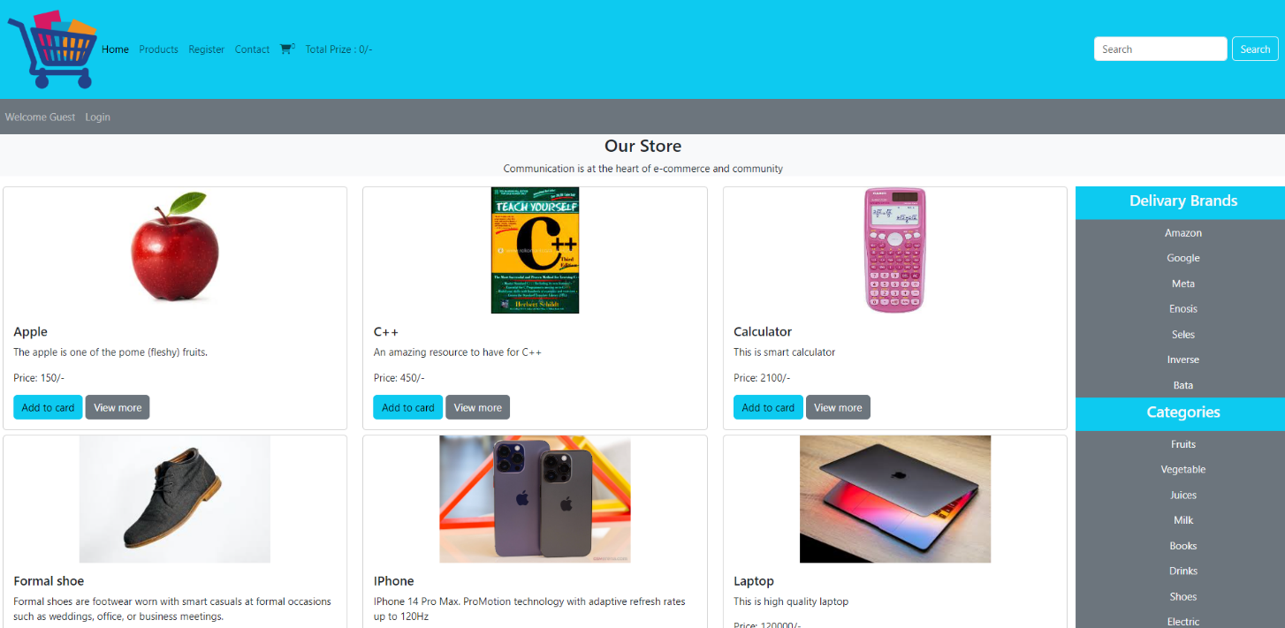

Figure 1: Homepage 1

It is in login status and currently showing username. My Account instead of registration

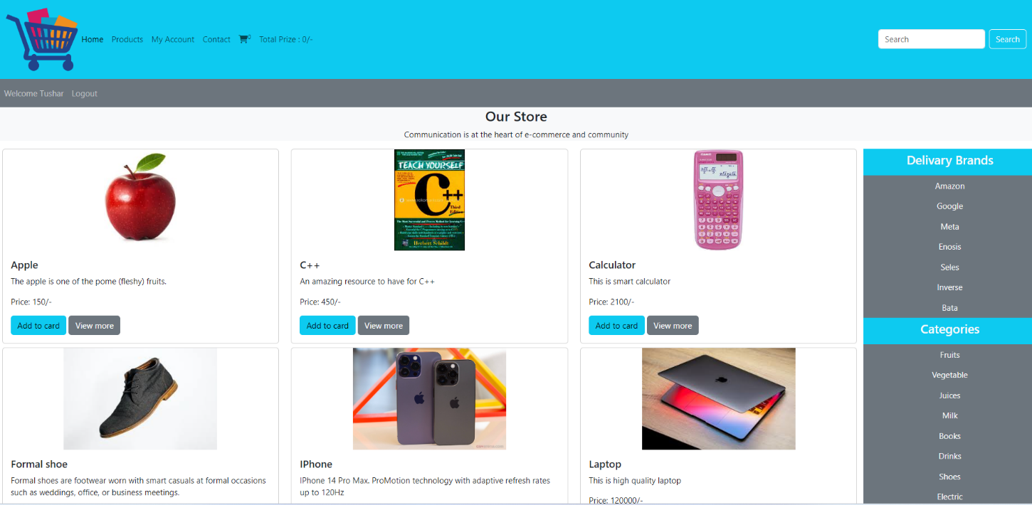

Figure 2: Homepage 2

**Login and Registration Page :**

If you already have an account, then login with username and password, otherwise create a new account by clicking on registration below.

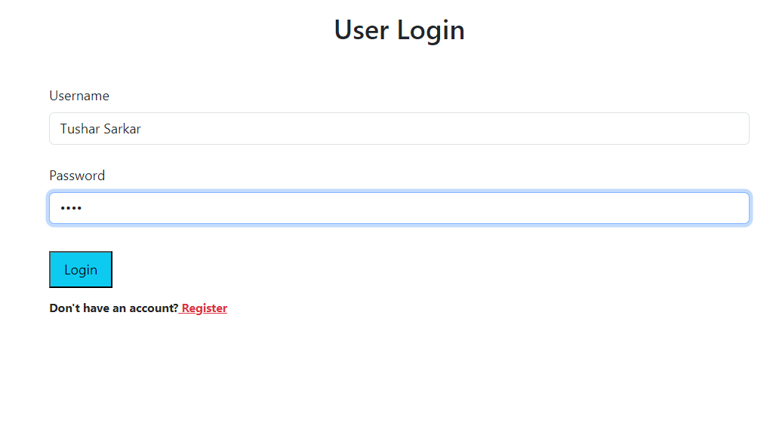

Figure 3: Login

Register with the required information otherwise if you have an account then login by clicking on login.

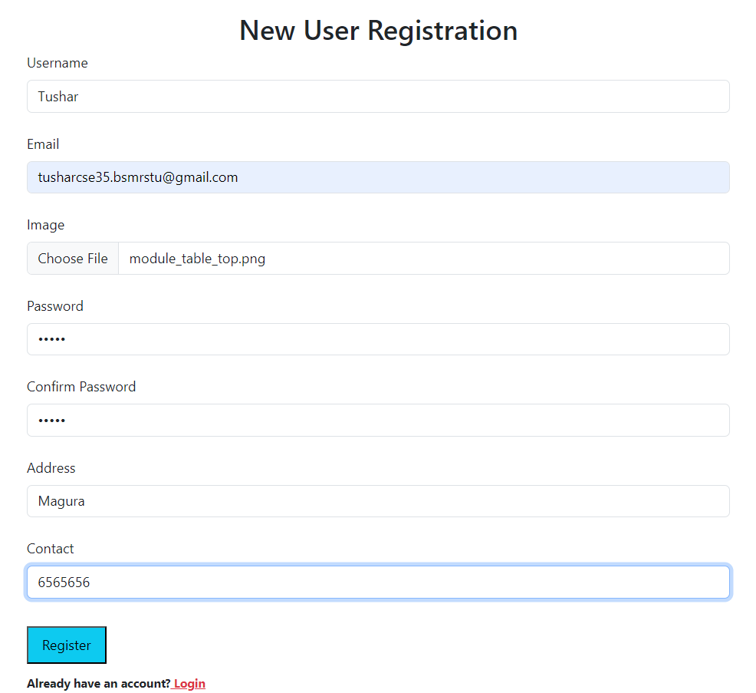

Figure 4: Registration

**View More:**

If you click on view more of each product, you can see more related products. From now on add can be carted or go to home page.

# 

Figure 5: View More

**My Account:**

If you click on My Account, your account will be displayed. Here you can see how many products you have ordered, how many pending products you have. You can edit your account and delete and logout your account.

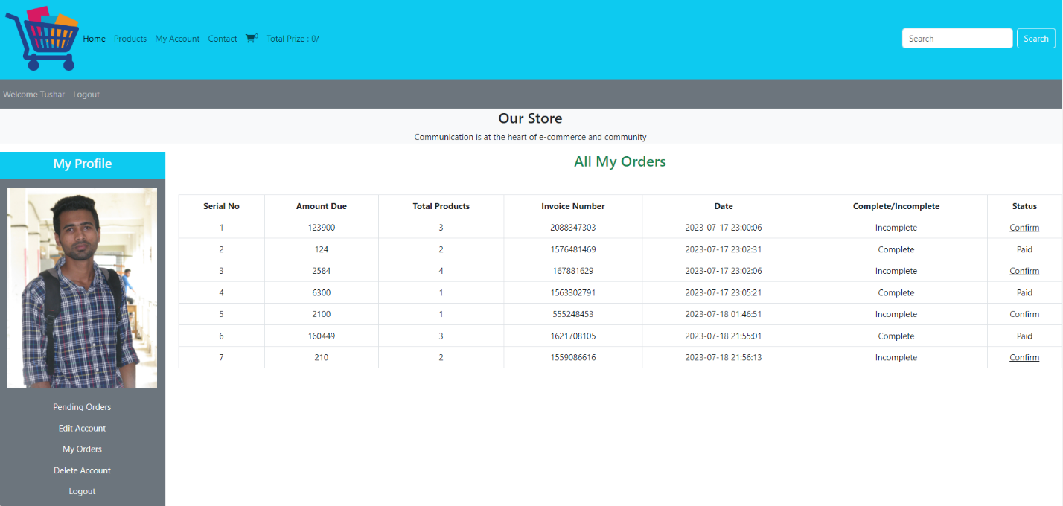

Figure 6: My Account

**Add to Cart:**

Clicking on add to cart on any product while on home page or products will add to the above cart. Then if you click on that cart, the following page will be displayed. You can increase or decrease the quantity and delete as well. If you want to buy more products, you can go to Continue Shopping. Finally click on checkout and your product will be ordered.

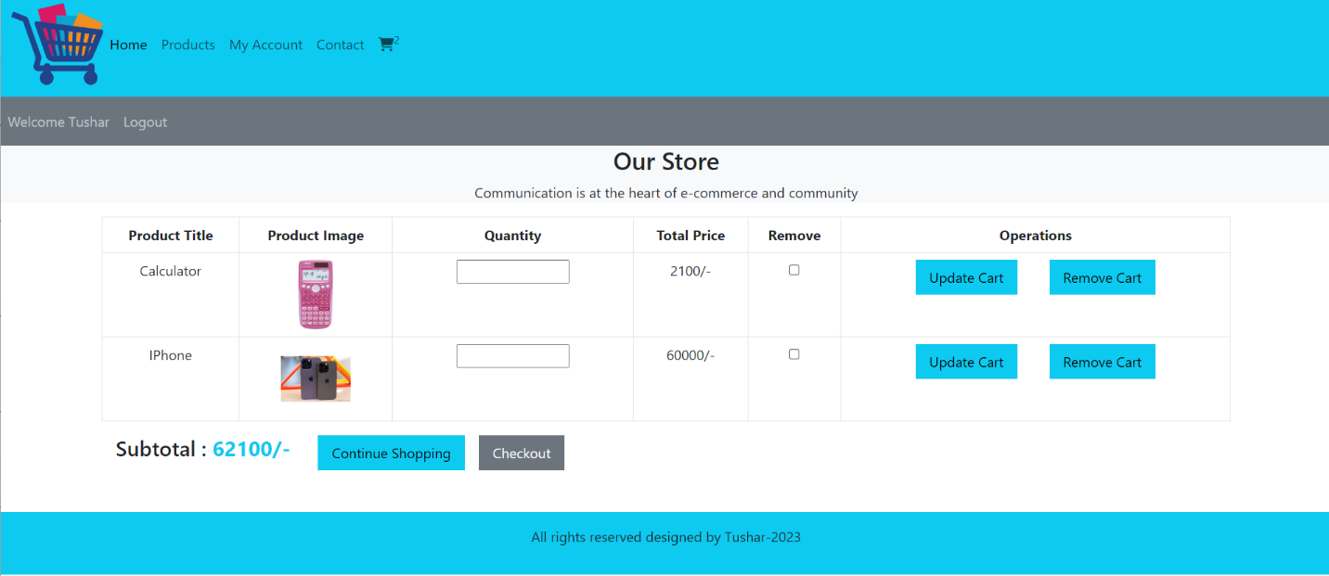

Figure 7: Add to Cart

**Order:**

After checkout this page will appear. Where two types of payment options can be ordered. After ordering, the 6th image will be displayed. And from there you can confirm the payment.

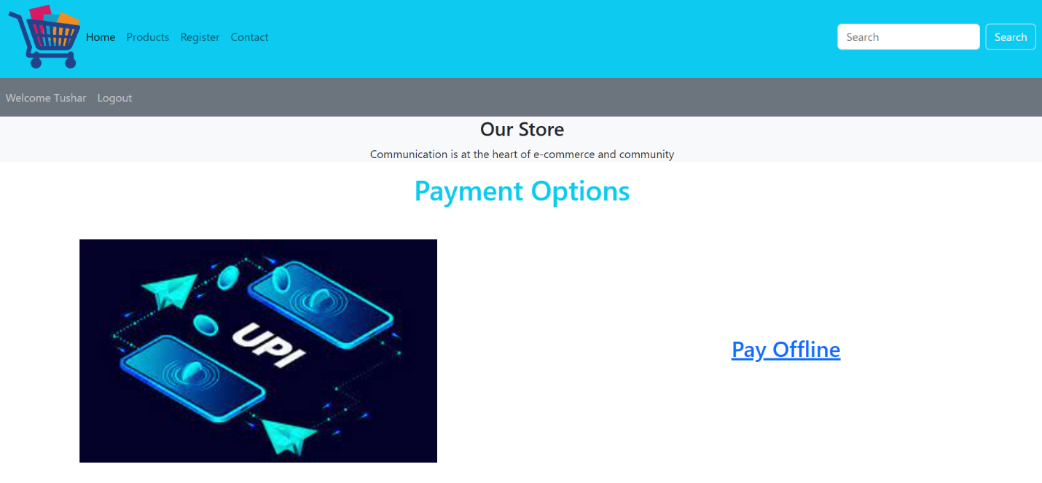

Figure 8: Order

**Payment:**

This is confirm payment state.

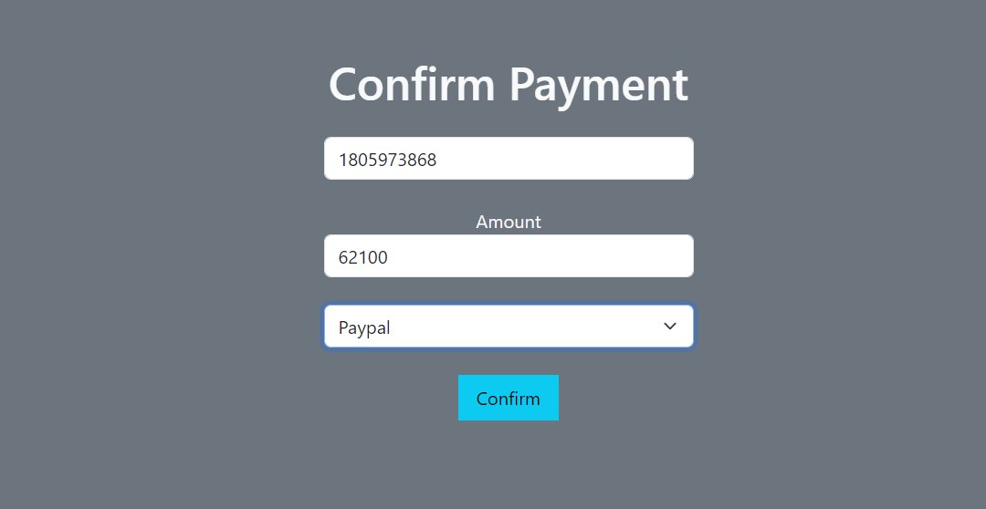

Figure 9: Payment

**Admin Homepage:**

This is admin panel. Here are some option and they are: Insert Products, View Products, Insert categories, etc.

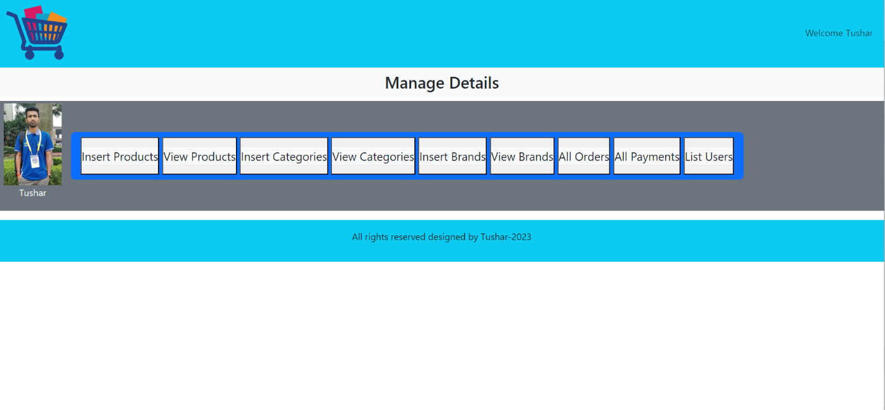

Figure 10: Admin Homepage

**Insert Products:**

Admin can insert product here with complete information.

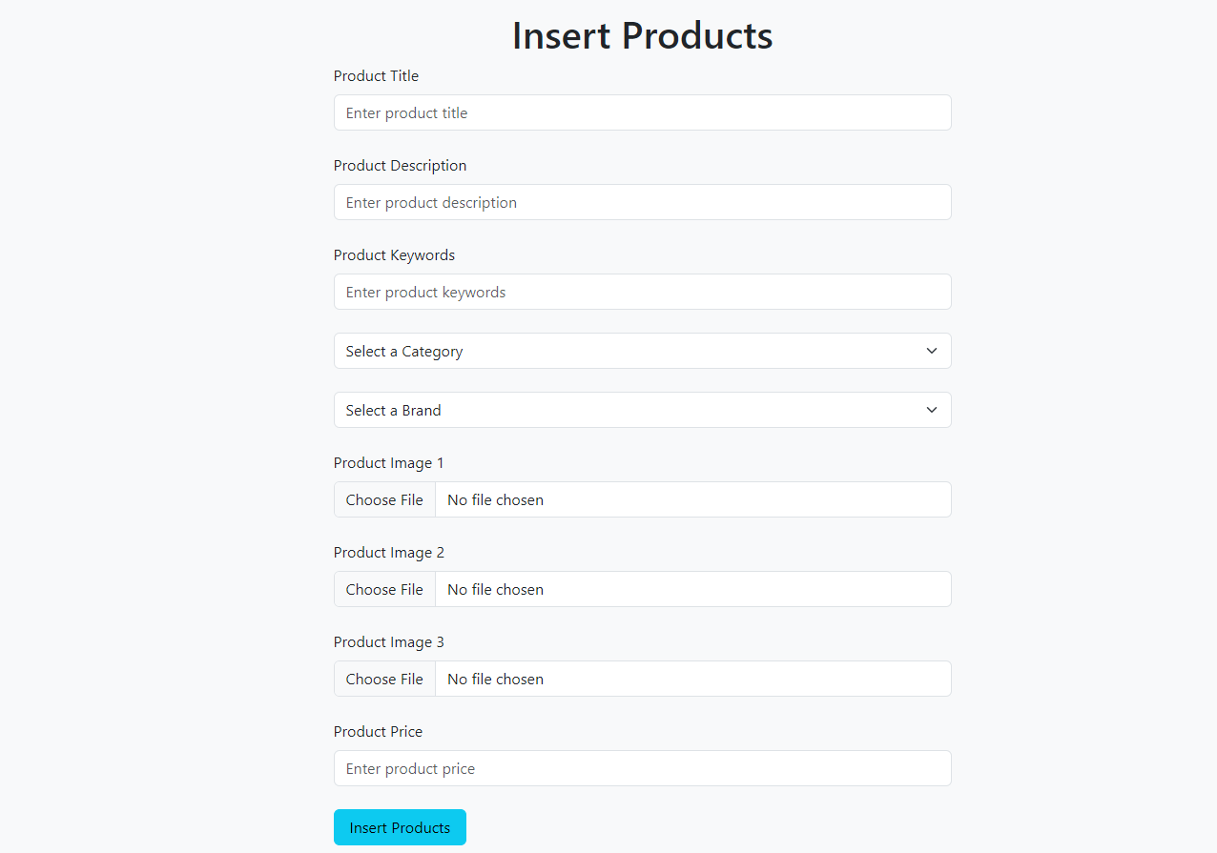

Figure 11: Insert Product

**View Products:**

All product admin insert courses can be seen on this page. How many products have been sold and can be edited or deleted here.

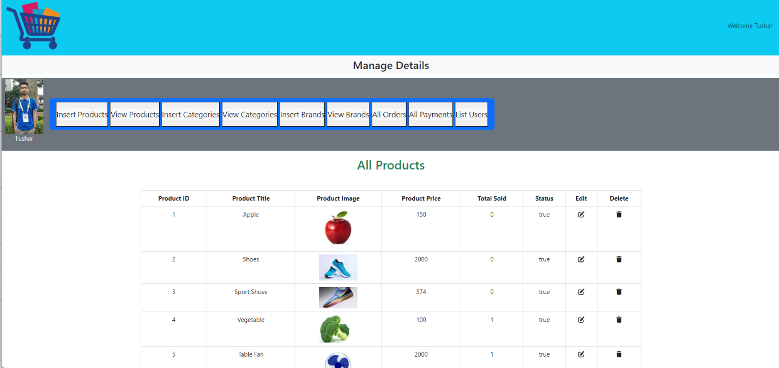

Figure 12: View Product

**Insert Categories:**

If you want to add any kind of product category, you can add it here.

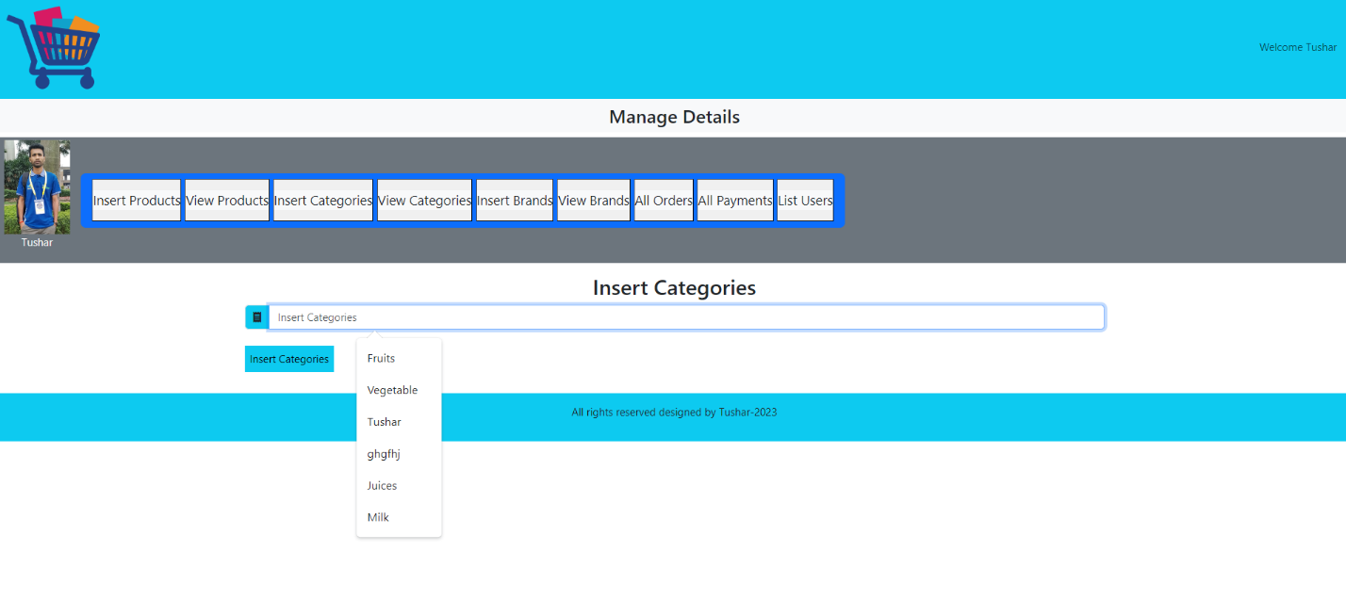

Figure 13: Insert Category

**View Categories:**

As many categories as are added can be seen on this page and can be deleted or edited.

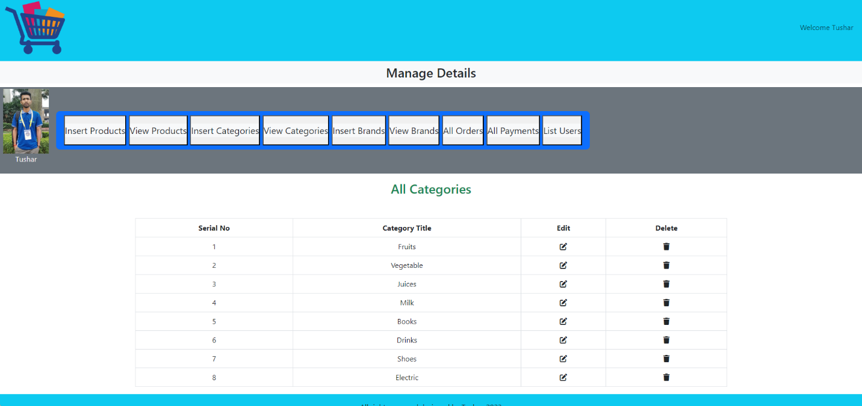

Figure 14: View Category

**Insert Brands:**

If you want to add any kind of product brand, you can add it here.

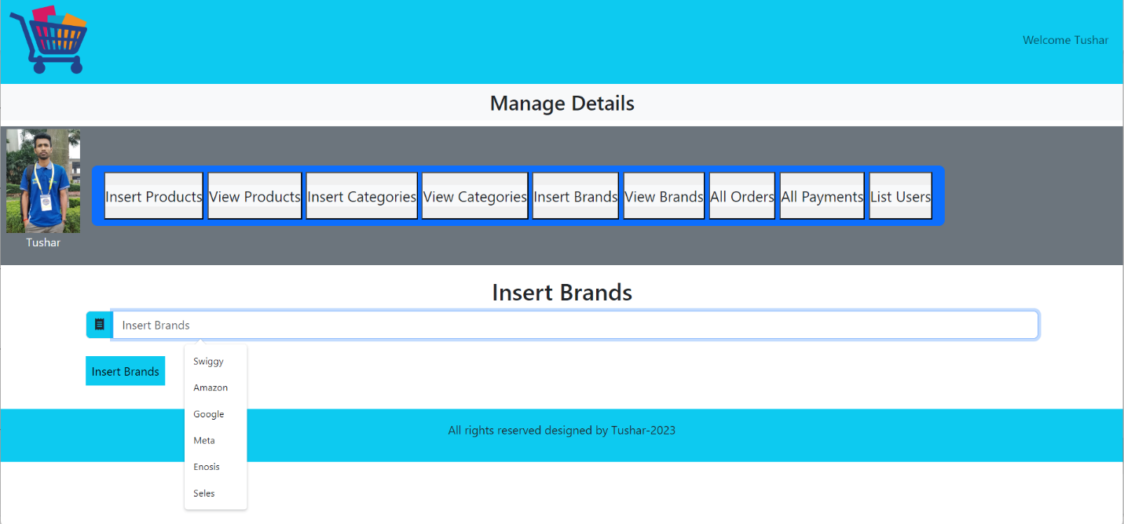

Figure 15: Insert Brand

**View Brands:**

As many brands as are added can be seen on this page and can be deleted or edited.

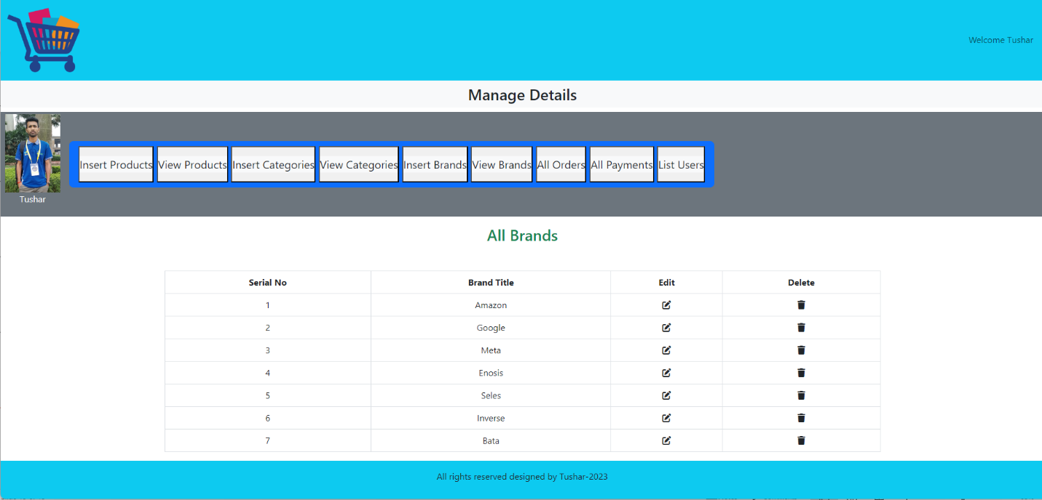

Figure 16: View Brand

**View Orders:**

**View Orders:**

The number of products ordered and payment confirmed by users can be seen on this page.

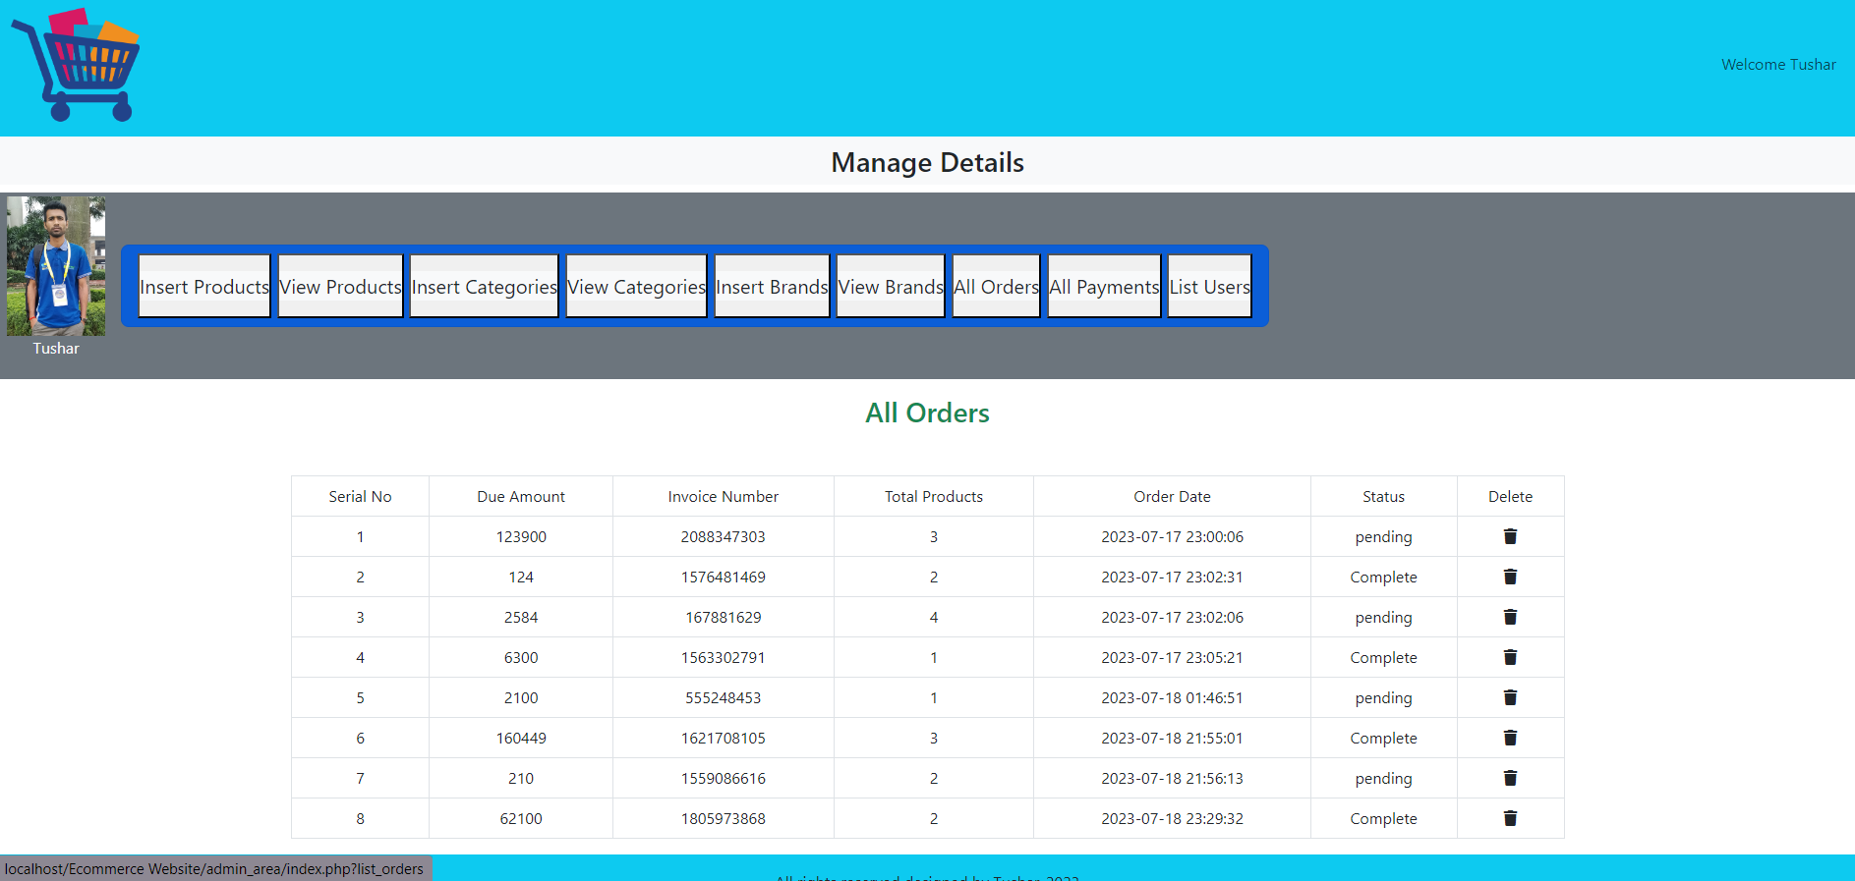

Figure 17: View Orders

**View Payment:**

Only the list of orders paid by users will be displayed on this page.

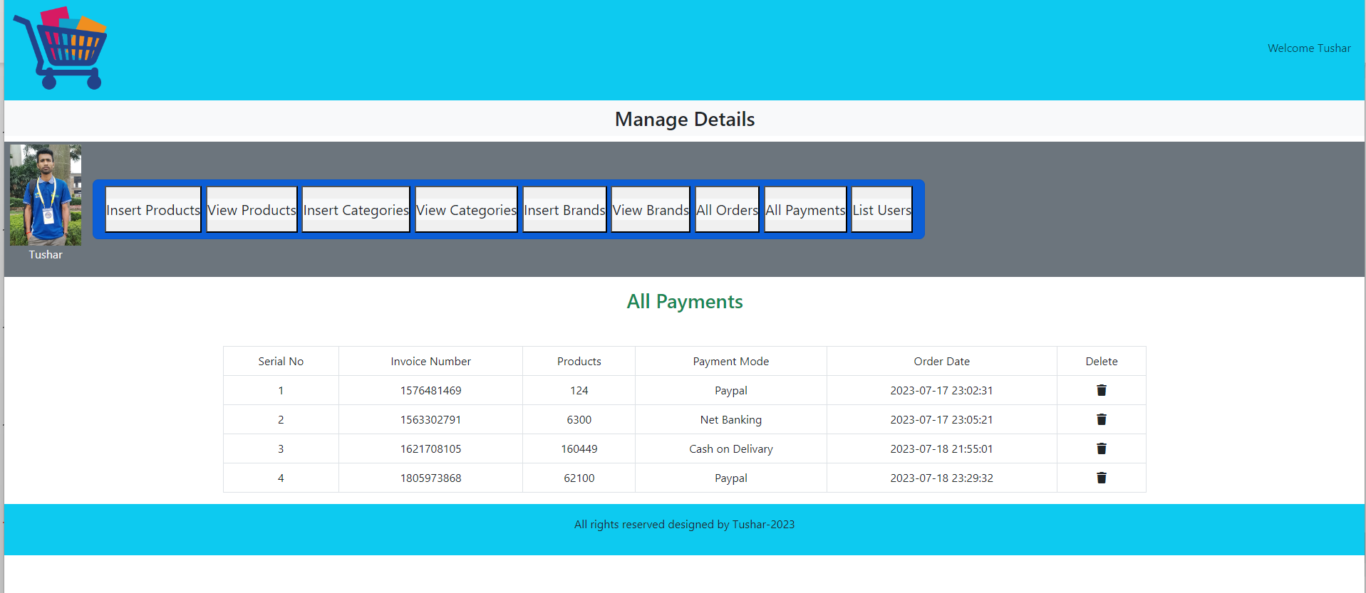

Figure 18: View Payment

**View User List:**

List of users creating accounts on this website.

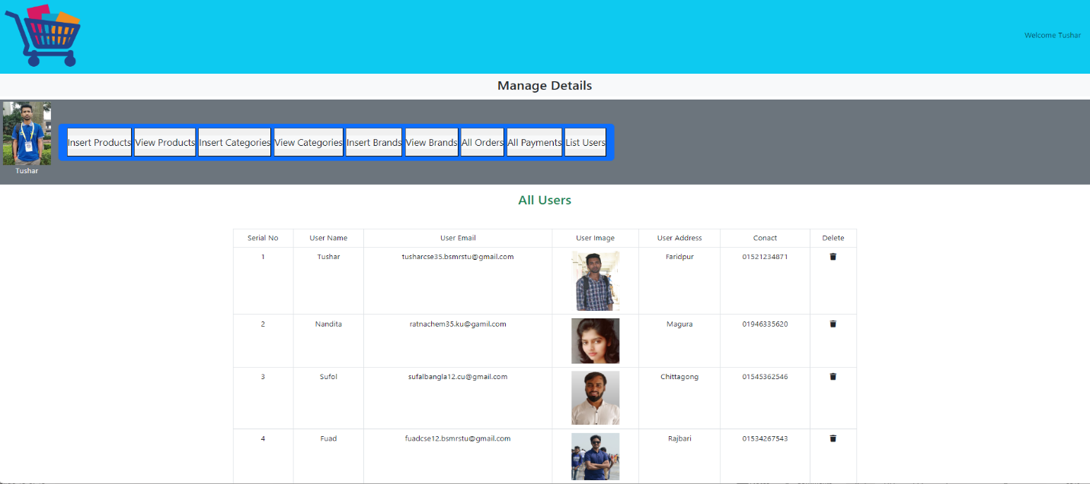

Figure 19: View Users

**Sample Code Implementation:**

Many such files had to be coded to create the complete website. The sample of the connection file is shown.

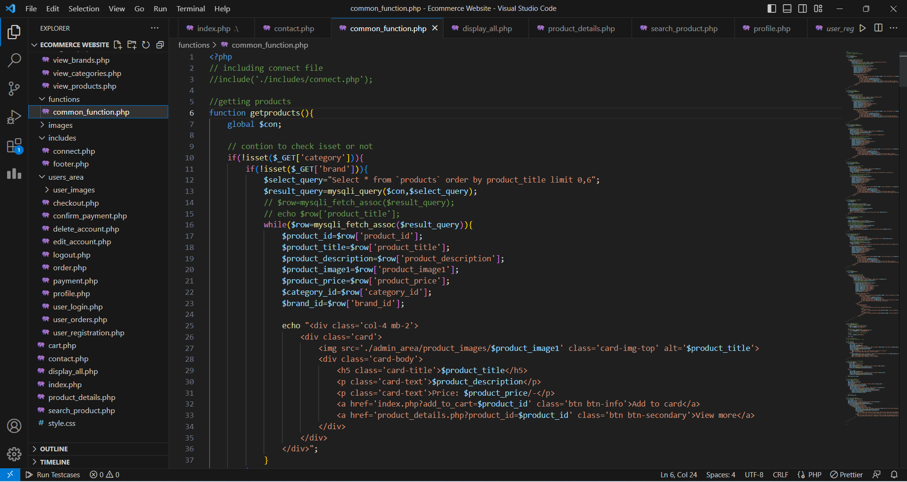

Figure 20: Sample Code

**Localhost php MyAdmin:**

All data is stored here. Insert is deposited here. If deleted, it will be removed from the database and selected and used for any task from here.

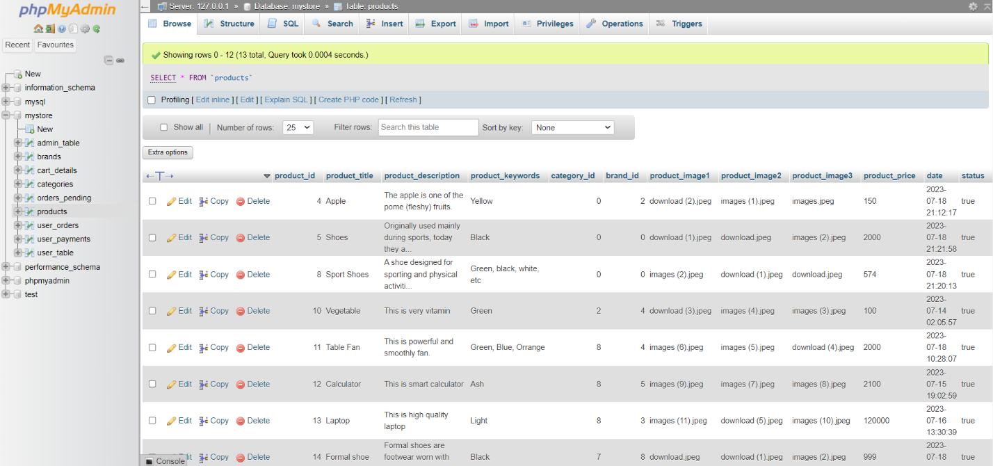

Figure 21: php MyAdmin

# **CHAPTER - 4**

# **LIMITATION AND FUTURE SCOPE**

## **4.1 Limitation:**

E-commerce websites come with their own set of limitations, despite their numerous advantages. Some of the key limitations include:

**Lack of Personal Interaction:** Unlike traditional brick-and-mortar stores, e-commerce websites lack face-to-face interactions with customers. This absence of personal touch can sometimes lead to decreased trust, especially in cases where customers have questions or concerns about products.

**Security Concerns:** Online transactions involve the exchange of sensitive information, such as credit card details and personal data. Security breaches or data theft can harm a business's reputation and deter customers from making purchases, highlighting the importance of robust security measures.

**Intense Competition:** The online marketplace is highly competitive, with numerous businesses vying for the attention of consumers. Standing out and gaining visibility amidst the competition requires strategic marketing efforts.

**Digital Divide:** While e-commerce has gained widespread adoption in many regions, there are still areas with limited internet connectivity or digital access, hindering the reach of e-commerce platforms to some potential customers.

**Regulatory Compliance:** E-commerce websites must adhere to various legal and regulatory requirements, including data protection laws, consumer protection regulations, and tax compliance, which can be complex and time-consuming to navigate.

Despite these limitations, businesses can mitigate many challenges by implementing strong security measures, offering excellent customer support, optimizing website performance, and investing in strategic marketing and customer engagement strategies. Understanding and addressing these limitations can lead to a successful and sustainable e-commerce operation.

## **4.2 Future Scope:**

In a nutshell, it can be summarized that the future scope of the project circles around maintaining information regarding:

* Mobile Commerce (M-Commerce)
* Augmented Reality (AR) and Virtual Reality (VR) Shopping
* Artificial Intelligence (AI) and Machine Learning (ML)
* Voice Commerce
* Same-Day Delivery and Fulfillment Centers
* Sustainability and Ethical Consumerism
* Social Commerce
* Blockchain Technology
* Personal Data Protection
* Customization and 3D Printing

E-commerce was not popular among many of us until very recently. Most of us were apprehensive about the concept. We could not really put our trust in online shopping websites to provide good quality products and services. Over time, as it gained popularity within the younger generation, e-commerce started blooming.

However, when the coronavirus pandemic hit the world, we were all confined to our houses, it became impossible for us to physically go out and buy the things that we wanted. I think this is when the rest of the world really started trying out e-commerce services. They realized that reputable online shopping websites provided numerous options and remarkable services.

The scope of e-commerce in India bloomed during the pandemic. This success can also be the result of increased internet use among our generation. The soaring popularity of e-commerce websites can be rightly called a ‘positive impact of covid-19 on e-commerce. Some of the most successful e-commerce business 2022 are Amazon, Flipkart, etc. One of the biggest benefits of e-commerce to business is that an e-commerce website makes it easy to sell products to a larger audience, no matter where their physical location is. India has shown rapid growth in the eCommerce sector. It is now brimming with job opportunities and service provider

Our project is only a humble venture to satisfy the needs in an Institution. Several user-friendly

coding has also adopted. This package shall prove to be a powerful package in satisfying all the

requirements of the organization.

The objective of software planning is to provide a frame work that enables the manger to make

reasonable estimates made within a limited time frame at the beginning of the software project and

should be updated regularly as the project progresses. Last but not least it is no the work that played the

ways to success but ALMIGHTY

# **CHAPTER - 5**

# **CONCLUSIONS**

An e-commerce website serves as a virtual storefront for businesses, providing them with a platform to showcase and sell their products or services online. The significance of such websites stems from their ability to break down geographical barriers, allowing businesses to reach customers worldwide and tap into a vast and diverse market. Consumers benefit from the convenience of shopping from the comfort of their homes, with 24/7 accessibility and a wide selection of products to choose from. E-commerce websites offer numerous advantages, including cost-effectiveness for businesses due to reduced overheads compared to physical stores.

Moreover, they enable data collection and analysis, providing valuable insights into customer behavior, preferences, and market trends. This data-driven approach allows businesses to personalize the shopping experience, leading to increased customer satisfaction and loyalty. Additionally, e-commerce websites can seamlessly integrate with other online channels and social media platforms, creating an omnichannel presence that enhances customer engagement. As technology continues to advance, e-commerce continues to evolve, offering businesses emerging opportunities in various sectors and markets. Embracing e-commerce empowers businesses to thrive in the digital era, driving growth and success in the highly competitive online marketplace.

# **CHAPTER - 6**

# **REFERENCES**

1. <https://www.w3schools.com/php/>
2. https://www.youtube.com/watch?v=7S_tz1z_5bA
3. <https://www.youtube.com/watch?v=at19OmH2Bg4&list=PLu0W_9lII9aikXkRE0WxDt1vozo3hnmtR>
4. https://www.tutorialspoint.com/mysql/index.htm

***The End***